USER INTERFACE DESIGN
EXPERIMENT 2: Memory Recall Task using Figma

NAME: GAYATHRI BOOPATHY REG NO: 240701141

Aim of the Experiment
To analyse the effect of chunking on user memory by designing and evaluating a menu-based interface containing common application options such as Profile, Help, Notifications, Settings, etc.
This experiment directly relates the chunking and recall concept to the Menu Items UI shown in the project screenshots.

FRAME 1: Instruction Page (Menu Items Interface) Chunking Analysis of the Instruction Page
The instruction page explains how users should observe and remember the menu options displayed in the interface. Information is chunked into short, clear instructions to reduce cognitive load.

Key Observations
- · Users are informed that multiple menu options will be shown on the screen.
- · Instructions guide users to carefully observe icons and text labels such as Profile, Help, Notifications, etc.
- · Steps are presented in a simple and sequential manner.
- · Users are told that correct recall of menu items is important.

UI Benefits
- · Clear instructions improve task understanding.
- · Minimal text avoids confusion.

- · Start button clearly indicates the next action.
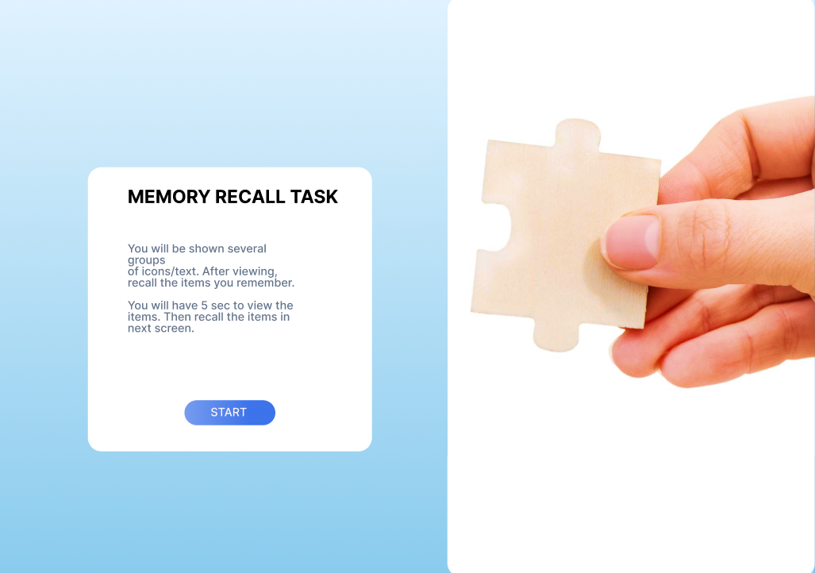

FRAME 2: Chunking Phase (Menu Items Display Screen) Analysis of the Menu Chunking Phase
This screen displays various menu options together for a limited duration. Users rely on chunking to remember the menu structure.

Key UI Components Menu Items Layout
- · Menu options such as Profile, Help, Notifications, Settings, Logout, etc. are displayed together.
- · Items are arranged in a structured layout with consistent spacing.
- · Icons and text labels help users form visual chunks.

Time Constraint
- · Limited viewing time encourages focused observation.

- · Users group related menu options mentally based on position and icon similarity.

How Chunking Works Here
- Users scan the menu options.
- Items are grouped mentally based on layout and visual similarity.
- Chunking reduces the effort required to remember individual options.

Cognitive Benefits
  - · Improves short-term memory of interface elements.
  - · Reduces overload when multiple menu options are present.
  - · Supports faster recognition during recall.

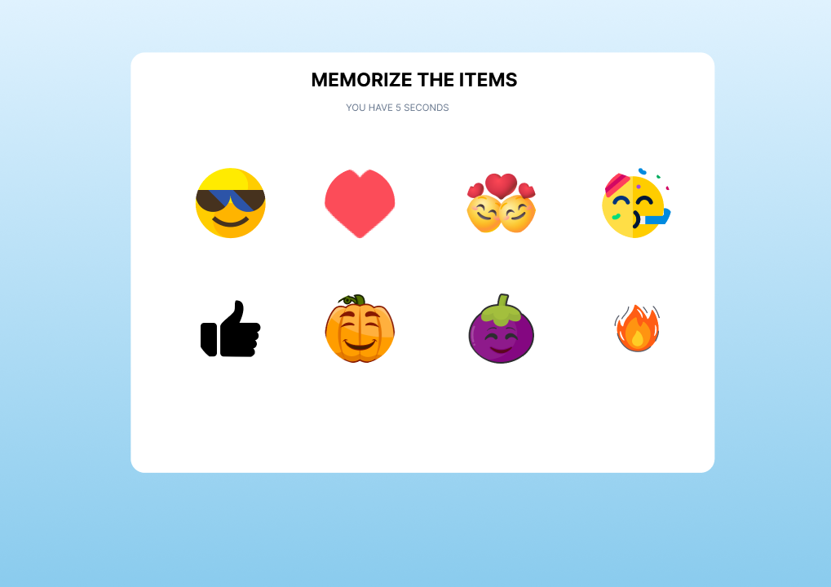

Analysis of the Recall Phase
This screen tests the user’s ability to recall menu options shown in the previous phase.

Key UI Components Menu Option Choices
  - · A combination of previously displayed menu options and new distractor options.
  - · Users select the options they remember seeing.

Submit Button
  - · Confirms the selected menu options.
  - · Proceeds to the result screen.

Working of the Recall Phase
- Users recall the menu layout from memory.
- Correct menu options are selected.
- Distractors help evaluate memory accuracy.

UX Benefits
  - · Simple selection interaction.
  - · Clear task flow.
  - · Effective evaluation of recall accuracy.

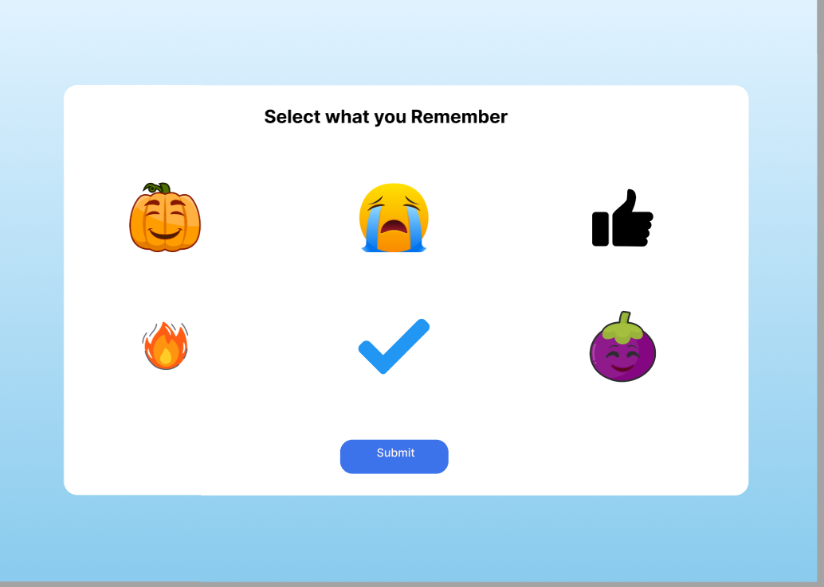

Analysis of the Result Page
This screen displays feedback based on the user’s recall of menu options.

Key UI Components Score Display
  - · Shows the number of correctly recalled menu options.
  - · Provides immediate performance feedback.

Action Buttons
  - · Continue: Move to the next set of menu options.
  - · Restart: Retry the same task.
  - · Exit: End the experiment.

Benefits

- · Helps users assess memory performance.
- · Encourages repeated learning.
- · Gives users control over navigation.

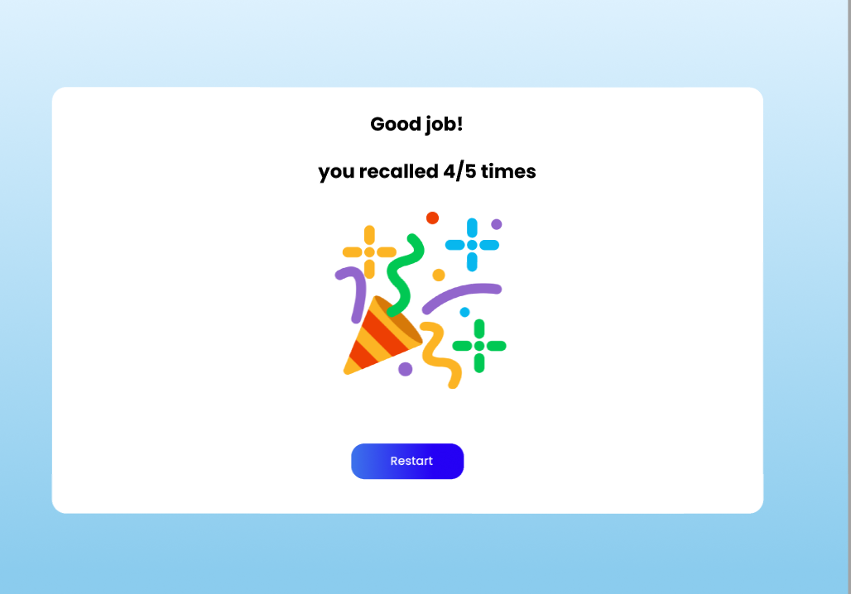

Links:

https://www.figma.com/proto/HR3XQzioiw1eupWcrjzCwb?node-id=0-1&t=3VxDRjHixmrYlIIS-6

Result:
The designed interface effectively demonstrates that chunking improves memory recall.

